**HW#4: Recommendations**

**Kansas City:**

There are two competitor stores in this location. However, the competitor's average weekly sales per square foot is relatively low, at $.10 average weekly sales per square foot. Furthermore, each holiday's average weekly sales per square foot are ranked (out of 15) as #12 for Thanksgiving and Superbowl, #13 for Labor Day, and #14 for Christmas at the DMA level. This location is also ranked #13 in average weekly sales per square foot for an average non-holiday week. This is because the square footage of the two stores, #25 and #38, are 39690 and 128107, respectively. The ample square footage significantly reduces the average sales per square foot. Kansas City would be an excellent location for a new store because its average weekly sales per square foot is low. If the store were smaller than the two competitor stores, then the store would be successful, with a higher average weekly sales per square foot..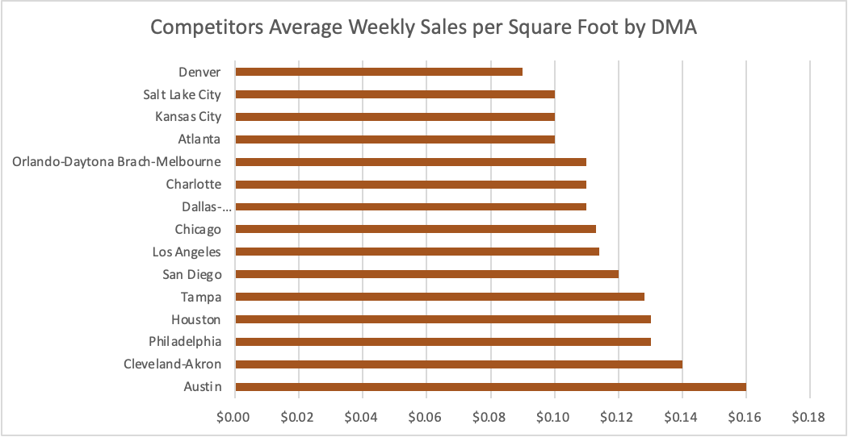

**Orlando-Daytona Brach-Melbourne:**

There is one competitor store in this location. However, the competitor's average weekly sales per square foot is high, at $.11 average weekly sales per square foot. Orlando's average weekly sales per square foot are outside the top five DMA's for the highest average sales per square foot. The one store has the lowest average weekly sales per square foot for the Super Bowl (#15) and is ranked #11 for Labor Day. Orlando's store has sizeable square footage, 202505. The extensive square footage significantly reduces the average sales per square foot. Orlando-Daytona Brach-Melbourne would be an excellent location for a new store because there is only one competitor store in this location, and its average weekly sales per square foot is low.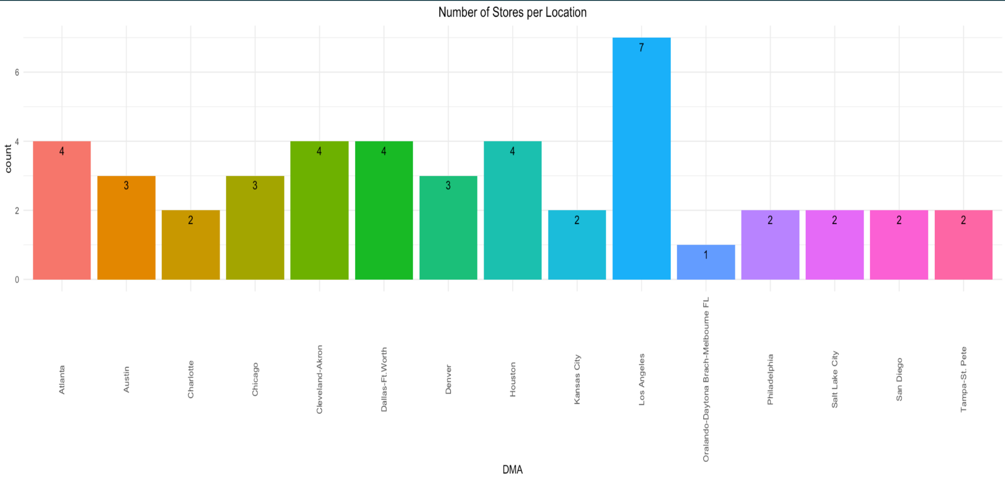

**Los Angeles:**

There are seven competitor stores in this location. However, the city is underserved. Right now, there are approximately 905k customers going to one store. The competitor's average weekly sales per square foot across all seven stores is high, at $.11 average weekly sales per square foot. Store #42, which has the best average weekly sales per square foot for each holiday, is ranked (out of 15) as #3 for Thanksgiving and Christmas, #2 for Labor Day and Superbowl. This store is also ranked #2 in average weekly sales per square foot for an average non-holiday week. Store #41 is ranked #41 (out of #45) for average weekly sales per square foot for the Super Bowl. This is because the two stores, #42 and #41, square footage is 39690 and 196321, respectively. This means that the ample square footage significantly reduces the average sales per square foot. Moreover, the average income in Los Angeles is $76,431. The store will be a "light" store; many customers will come since products will be cheaper at this store, meaning customers will be able to save money. It would be a great location to open a store. Even though one of Los Angeles' stores has great average weekly sales per square foot, Los Angeles would be an excellent location for a new store, especially because the city is underserved. 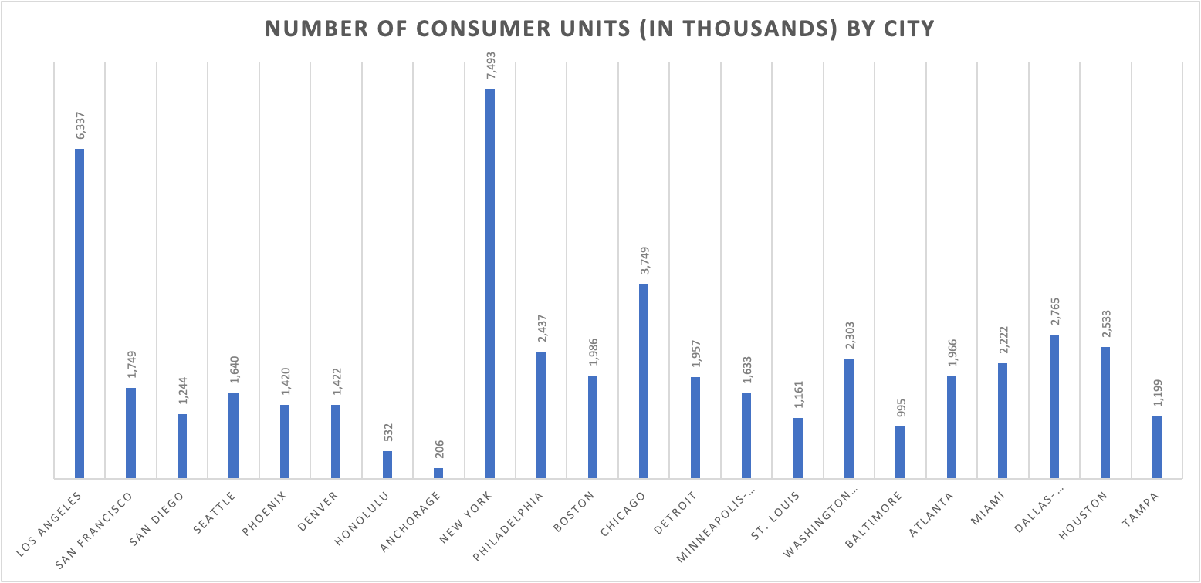

**Chicago:**

There are three competitor stores in this location. The city is underserved. Right now, approximately 1.2 million customers are going to one store. The competitor's average weekly sales per square foot across all three stores is high, at $.11 average weekly sales per square foot. All three of its stores are ranked in the middle for average weekly sales per square foot for each holiday and an average non-holiday week. The low average weekly sales is because the square footage of the three stores, #39, #12, and #29, are 184109, 112238, and 93638, respectively. This means that the two stores with ample square footage significantly reduce the average sales per square foot. Moreover, the average income in Chicago is $76,634. Even though Chicago's annual and food expenditures are lower than the average, the store will be a "light" store; many customers will come since products will be cheaper at this store, meaning customers will be able to save money. Chicago would be a great location to open a store, especially because the city is underserved. 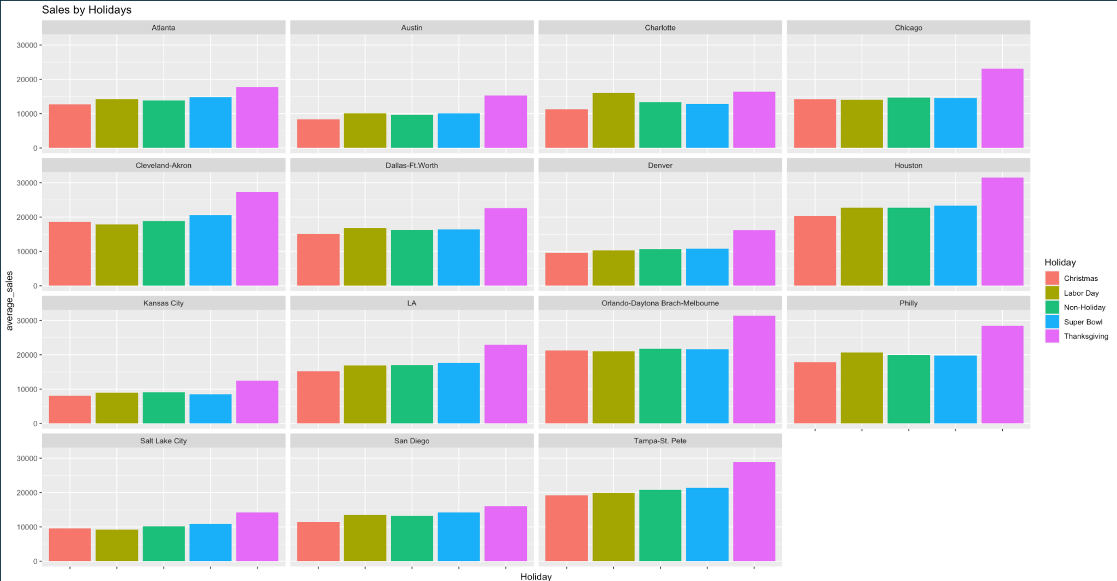

**Charlotte:**

There are two competitor stores in this location. The competitor's average weekly sales per square foot for the two stores is high, at $.11 average weekly sales per square foot. The two stores are ranked (out of 15) at the DMA level as #13 for Thanksgiving, Christmas, and Superbowl, and #4 for Labor Day for each holiday's average weekly sales per square foot. This location is ranked #13 in average weekly sales per square foot for an average non-holiday week. This is because of the square footage of the two stores, #40 and #17, 155083 and 93188, respectively. The one store with ample square footage significantly reduces the average sales per square foot. At the store level, the average weekly sale per square foot for each holiday is in the middle. Charlotte would be a great place to have a 55 thousand square foot (or less) store because the competitor's average weekly sales per square foot are low since those stores are large.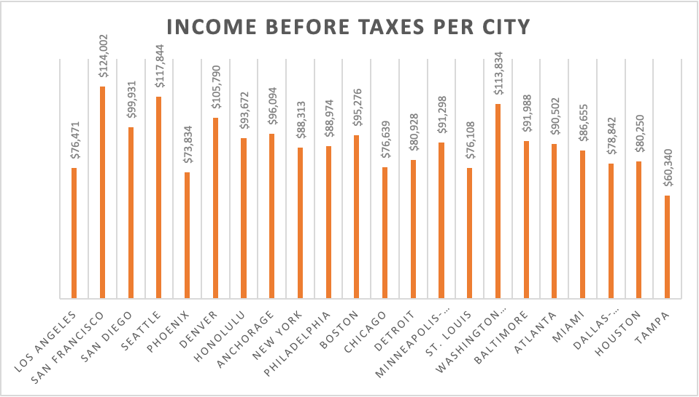

**Minneapolis-St. Paul:**

Minneapolis-St. Paul would be a great place to open a new store because there is no competition. There are approximately 1.6 million customer units, so there would be a lot of foot traffic and new customers. It is a high-income city, and the people spend $70487 on average annually. Furthermore, the food expenditure is high, and they will also purchase other products, such as Household furnishings/equipment and Personal care products. Moreover, the "light" concept would work here because customers like to save money when they can.

Minneapolis-St. Paul would be a great place to open a store, especially since there are no competitors.

**New York:**

New York would be a great place to open a new store because there is no competition. There are approximately 7.5 million customer units, so there would be a lot of foot traffic and new customers. It is a high-income city, and the people spend $67782 on average annually. Even though its food expenditures are low, customers will spend more on other products, such as Apparel. Moreover, the "light" concept would work here because customers like to save money when they can. New York would be a great place to open a store, especially since there are no competitors. 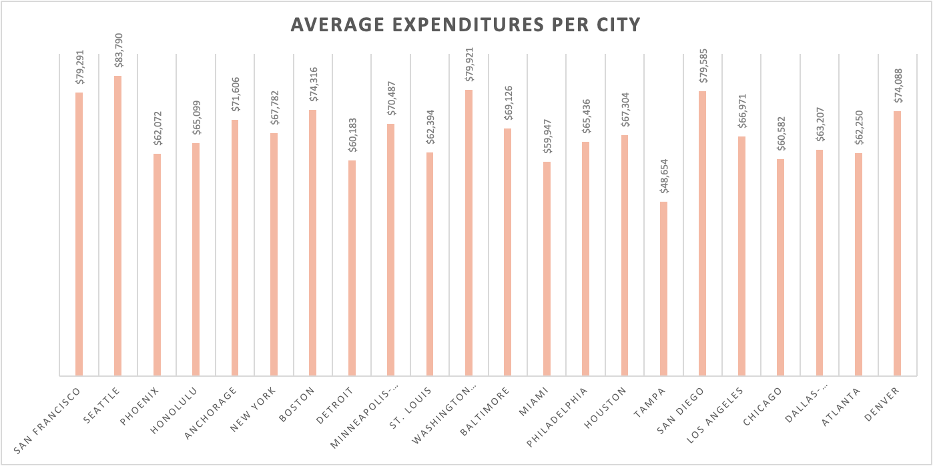

**Boston:**

New York would be a great place to open a new store because there is no competition. There are approximately two million customer units, so there would be a lot of foot traffic and new customers. It is a high-income city, and the people spend $74316 on average annually. Even though its food expenditures is on the lower side, customers will spend more on other products, such as Household furnishings/equipment. Moreover, the "light" concept would work here because customers like to save money when they can. Boston would be a great place to open a store, especially since there are no competitors.

**Seattle:**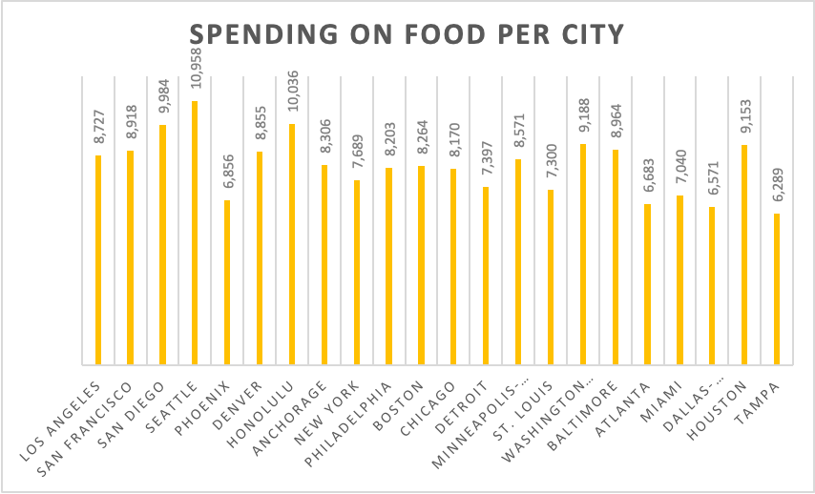

Seattle is a great place to open a store because there are no competitors. There are approximately 1.6 million customer units, so there would be a lot of foot traffic and new customers. It is a high-income city, and the people spend $83790 on average annually. People from Seattle spend the most on food, $10958 annually. They also spend a lot on other products, such as Household furnishings/equipment, Apparel, and personal products. Moreover, the "light" concept would work here because customers like to save money when they can. Seattle would be a great place to open a store, especially since there are no competitors.

**Miami:**

Miami is a great place to open a store because there are no competitors. There are approximately 2.2 million customer units, so there would be a lot of foot traffic and new customers. It is a mid-income city. The people spend $59947 on average annually. Even though its food expenditures is on the lower side, customers will spend more on other products, such as Household furnishings/equipment and Personal care products. Moreover, the "light" concept would work here because customers like to save money when they can. Miami would be a great place to open a store, especially since there are no competitors.